Angular: Getting stared Summary

Serviceware  
Mack Hodge

7 July 2022

## package.json

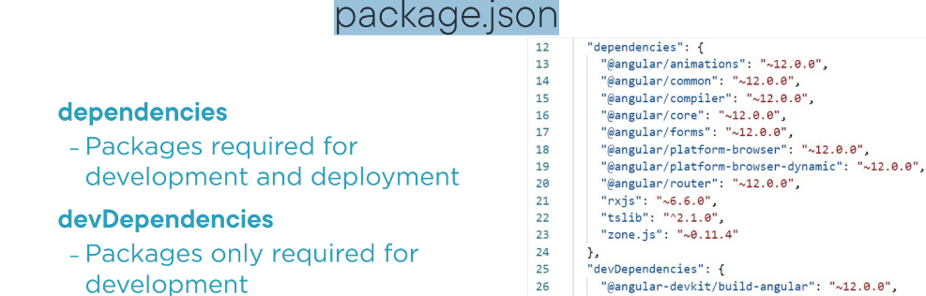

## When Setting Up Existing Angular Code

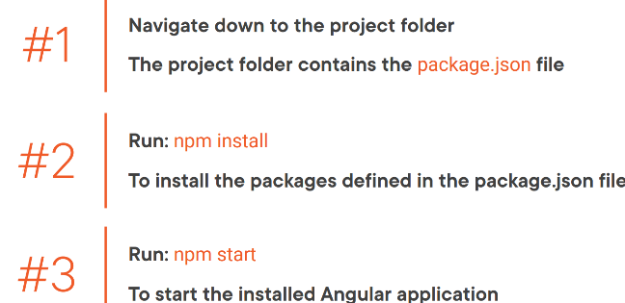

## Application Architecture

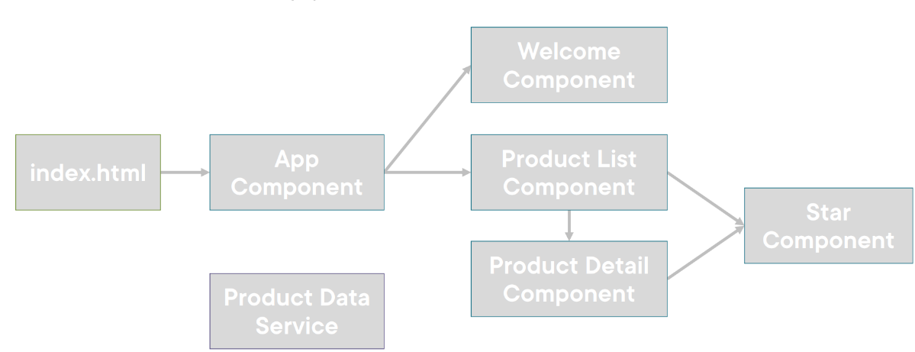

## What is a component?

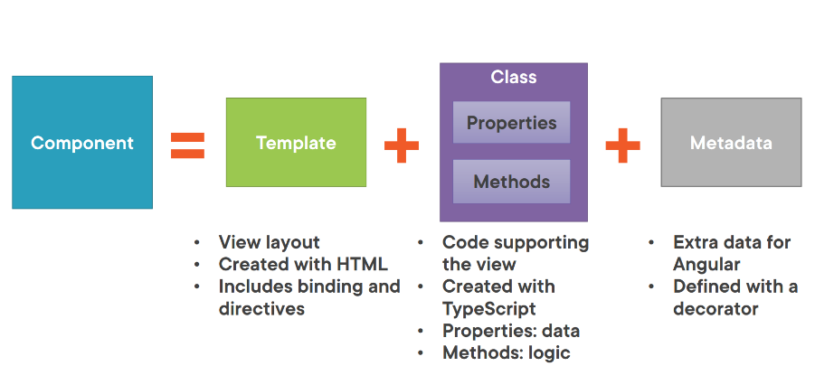

## Component

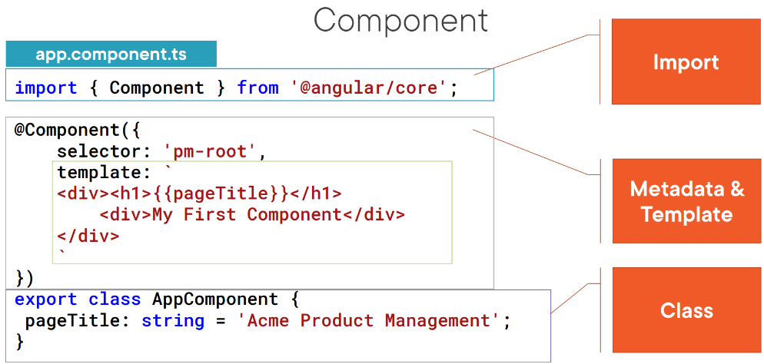

## Creating the Component Class 1

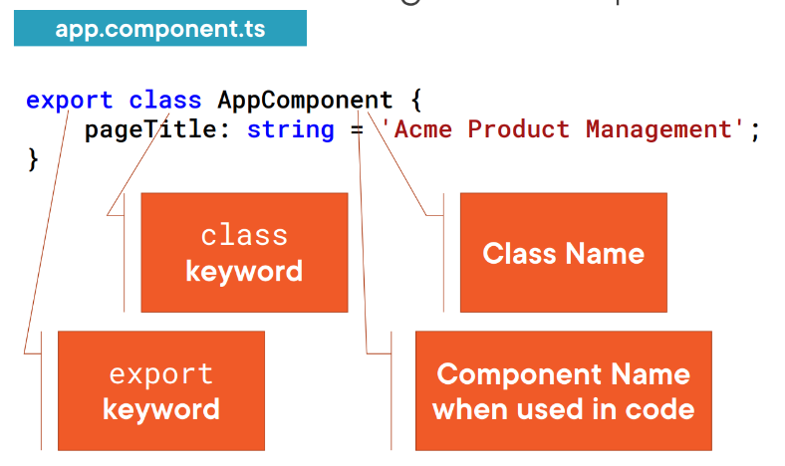

## Creating the Component Class 2

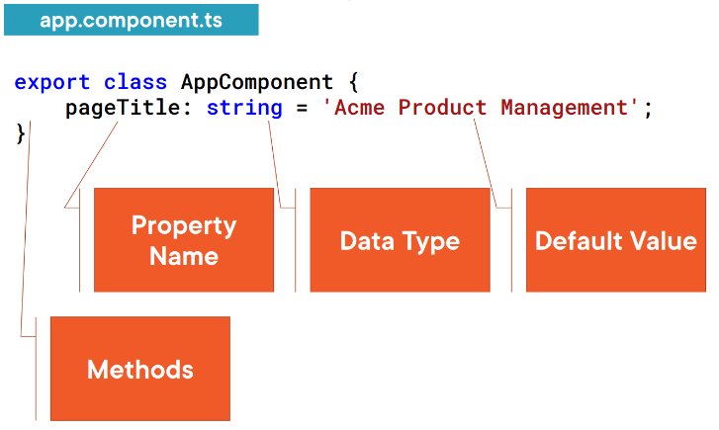

## Defining the Metadata

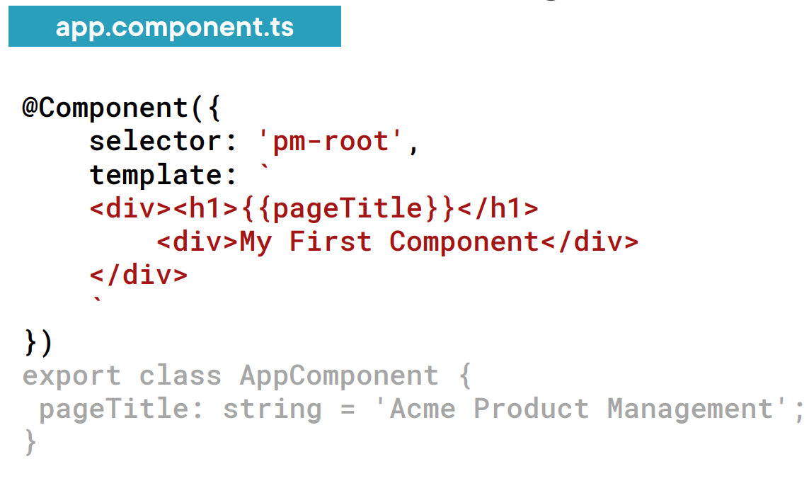

# **Templates, Interpolation, And Directives**

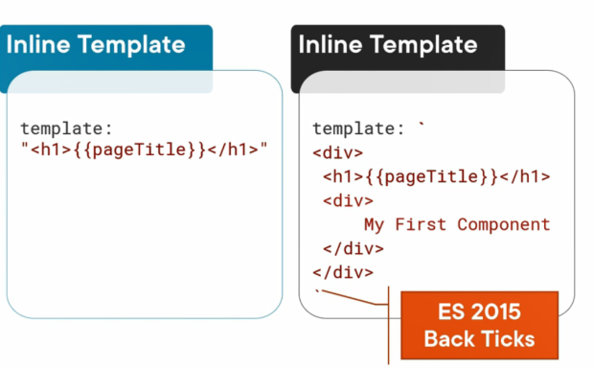

Back ticks   
**Pros**: Make the HTML more readable   
 Template is directly divined with in a component, keeping the code for the view in one file

**Const**: no intelliSense

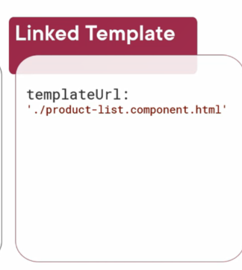

Linked template is a better approach

## Naming convention

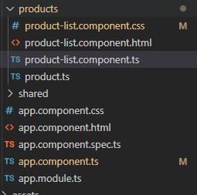

Use always use .component for a component

## Using component as a Directive

Selector means that we can use the component as a directive in any other component. Therefore, using this component elsewhere, we can also use its templates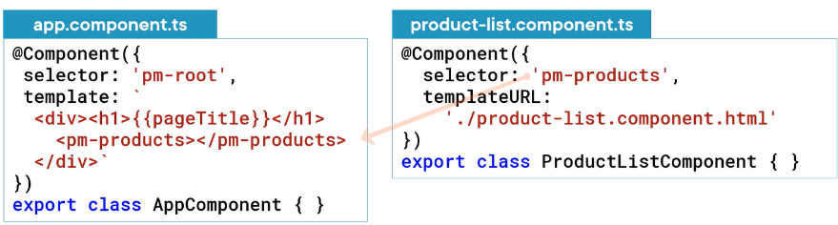 and the component properties.

**Quick note**

* Every page needs an app.module.ts that puts everything together
* AngularJs has such thing ?

## Binding with interpolation

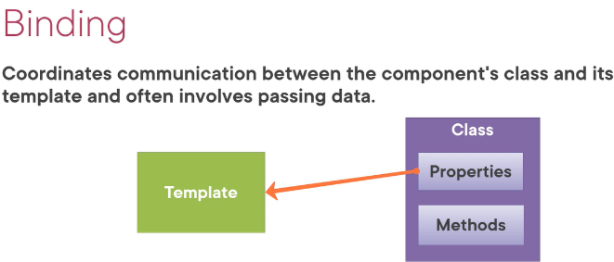

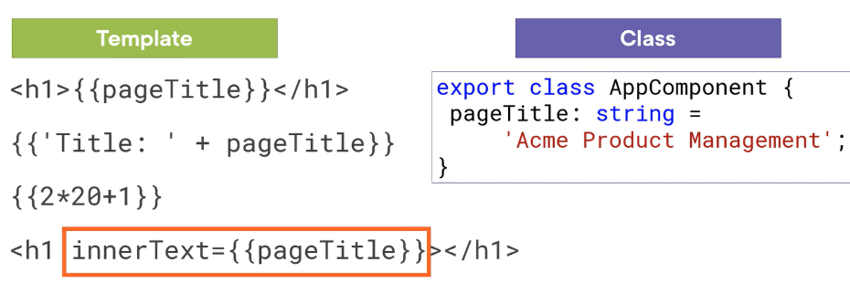

**Quick note**

* Interpolation is a one-way binding
* H1 is an template expressing, both h1 display the same thing

## Adding logic with directives

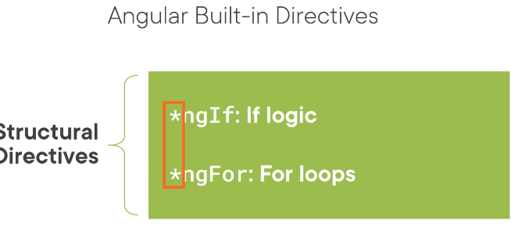

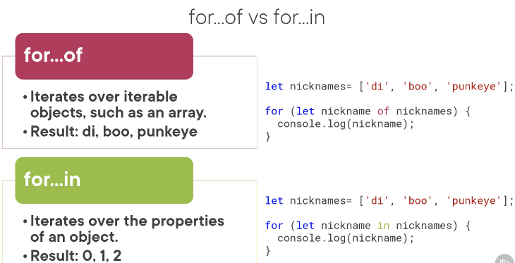

**Quick note**

* We can also use angular build in directive
* Notice the *
* Ng if length == 0 the dom is not shown
* BrowserModule is imported in the app module
* ngFor
* for ..of result in its properties for …in result in its index in the list
* Define local variable with let

# Data Binding & Pipes

## Handling Events

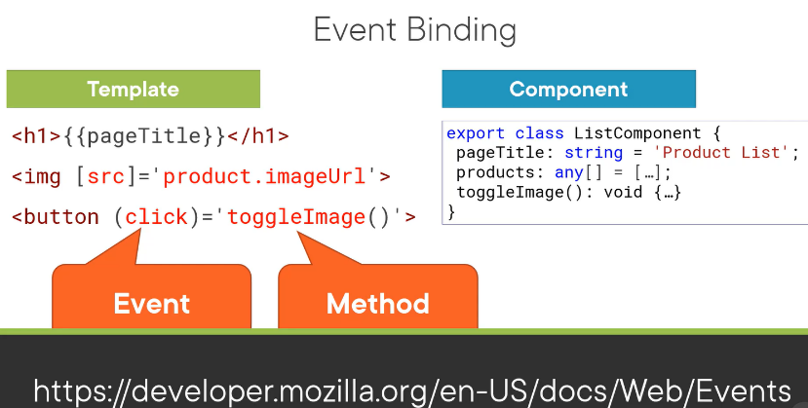

## Handling input with two-way binding

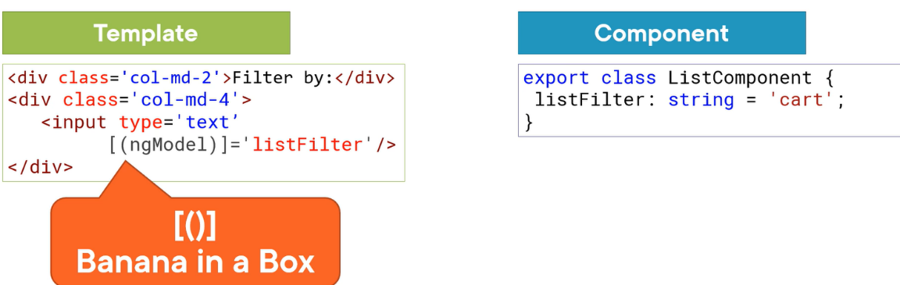

## Pipes

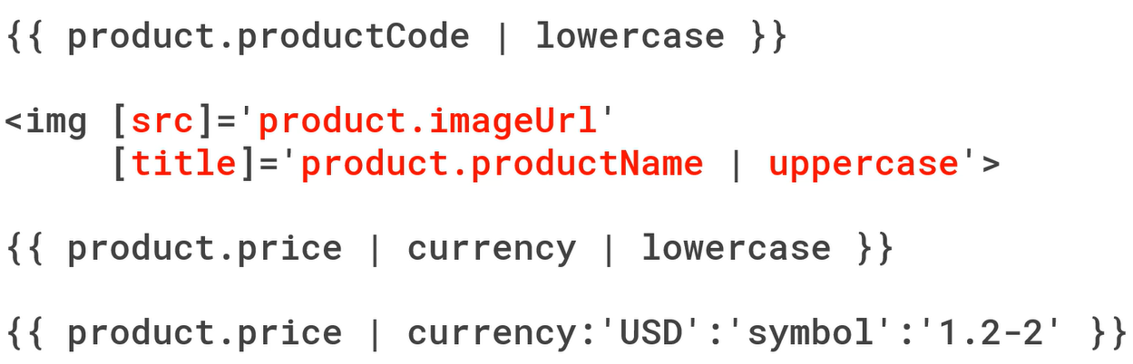

Note add form to the app module

# More on Components

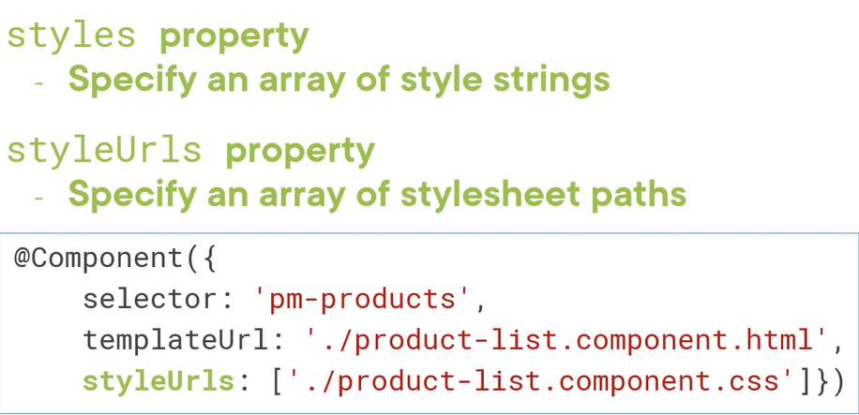

Lifecycle hook?

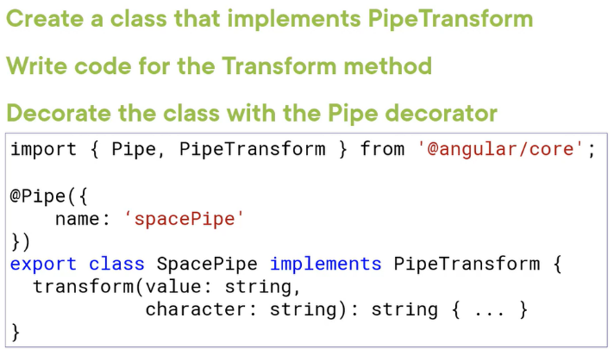

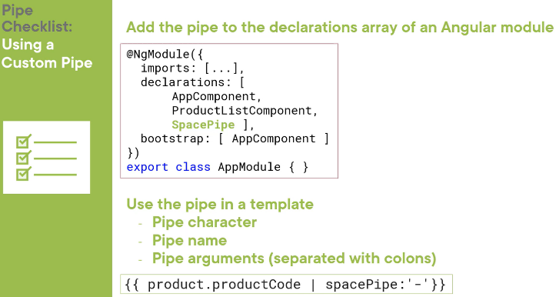

# Building Nested component

## Passing data to a nested component

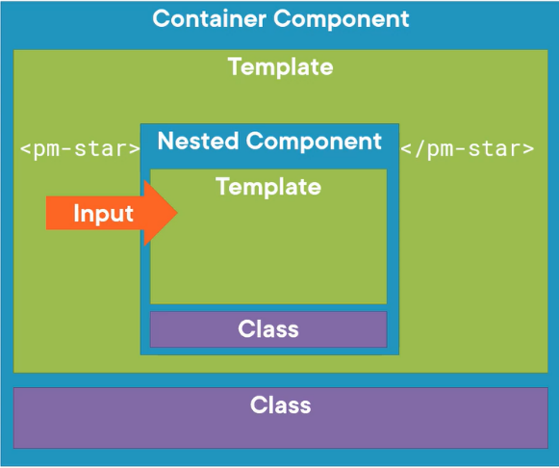

The main container passes input to the nested couponed using input properties

Note

* We can think of the properties decorated with the @input or @Output decorators as the public API of the component

**Summery**

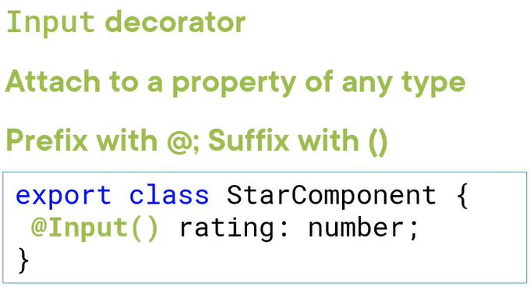

**-Property binding**

# Services and dependency Injection

**What is a service?**

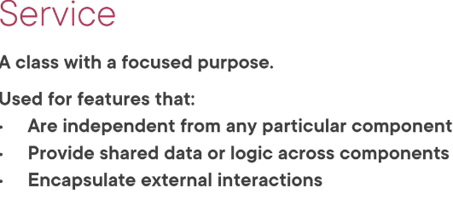

## Registering the Service

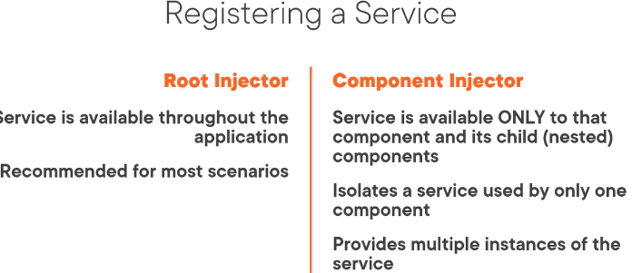

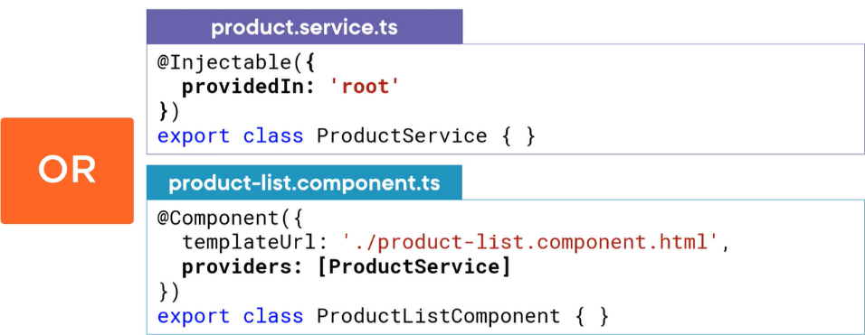

Root everywhere in the application

Only in product list component

In typescript you inject the service in the constructor

**Note**

* A sserice us a class with
* We can register an instance of the service class called a singleton, angular provides an angular injector
* A component inject the services as a dependency when its needs it

# Retrieving Data Using HTTP

Reactive extensions (RxJS)

* Transforming data using opertaoers (similar to LINQ)
* Angular uses RxJS
* Syncronous : real time
* Asyncronous: No imeddiate response
* HTTP is Asyncronous

-Observable , A collection of items over time , but it does not retain the items. Think of it like mouse move or button click (The way that the data moves)

-Observable do nothing until we subscribe. When we subscribe the observable start emitting notification   
- Tree types of notification

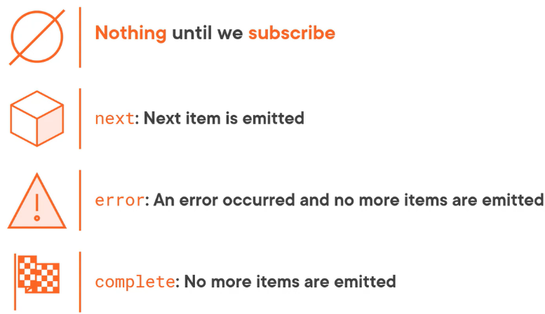

Observable Pipe

Fictitious operator: does something with the data when it gets it vb. Make this array of data Uppercase